Assignment - 3

|  |  |
| --- | --- |
| Name | Ramya priya S |
| Roll No | SSNCE195001122 |
| Date | 19 September 2022 |
| Team ID | PNT20222TMID53089 |
| Project Name | Project - Personal Expense Tracker App |

# Create a Bucket in IBM object storage.

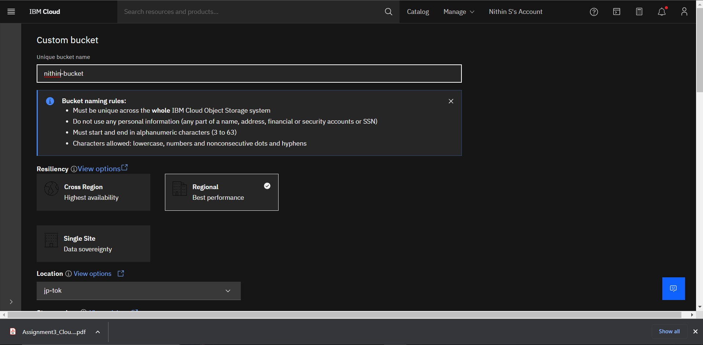

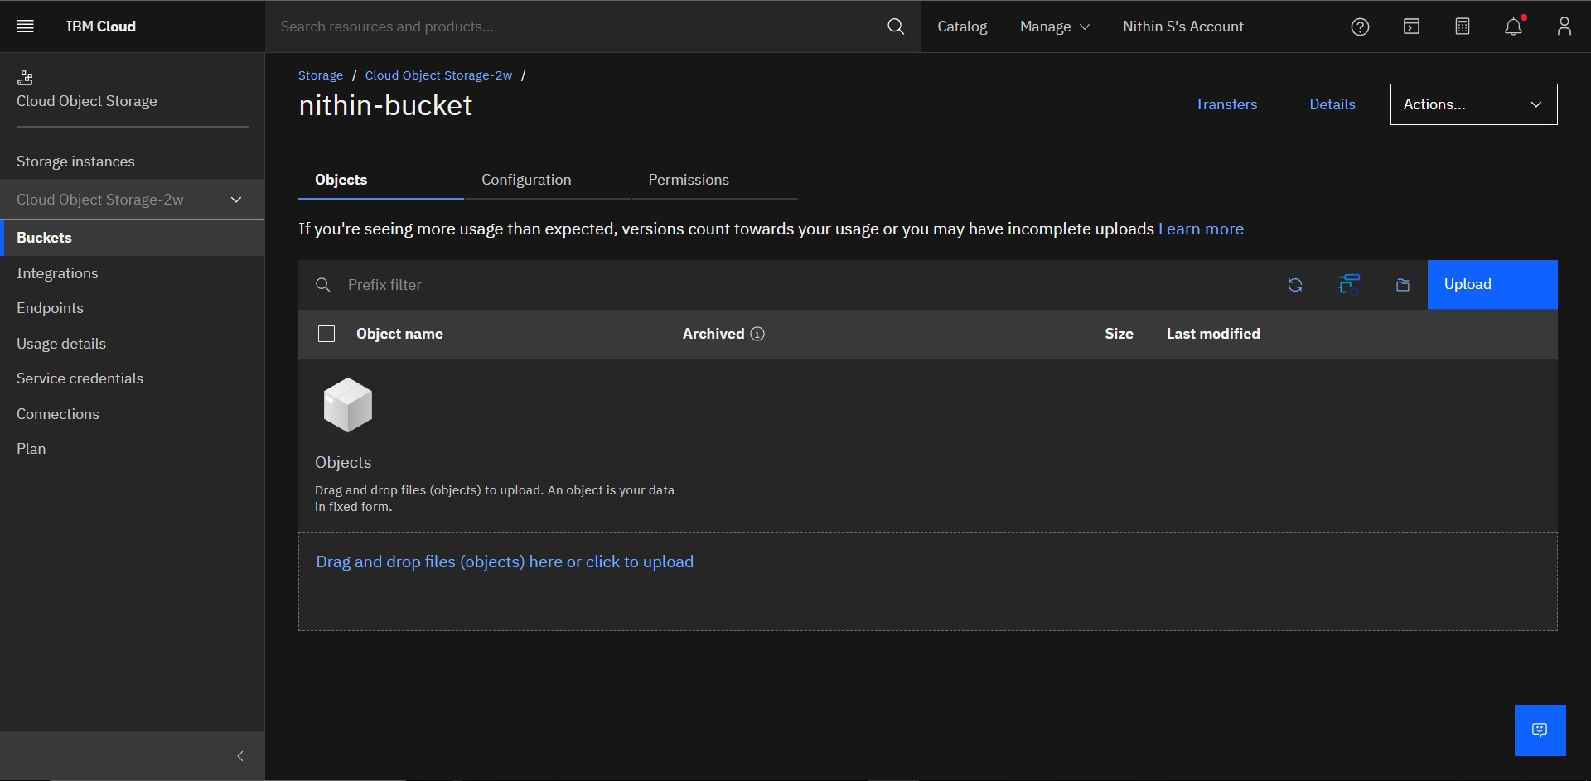

1. **Upload 5 images to ibm object storage and make it public. write html code to display all the 5 images.**

# Making the bucket public:

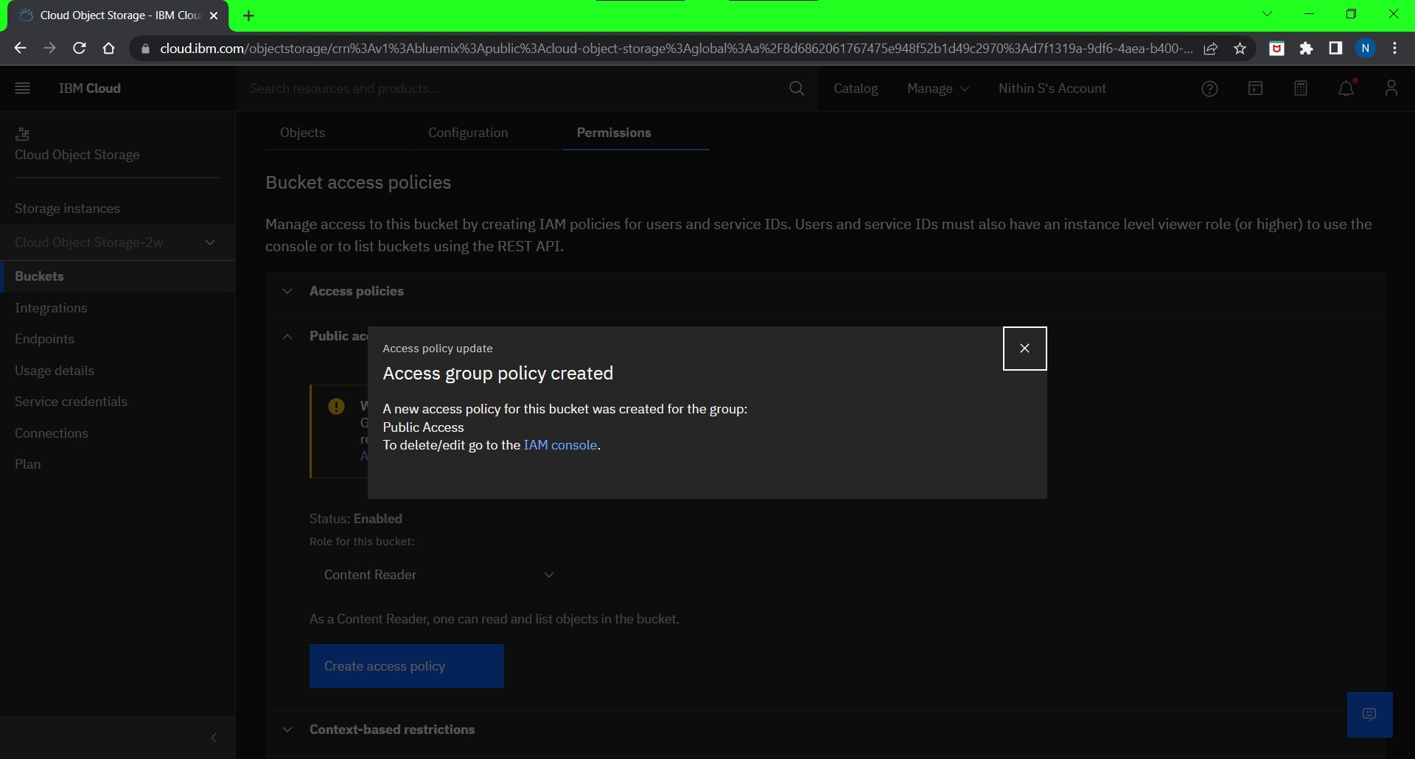

**Adding 5 images:**

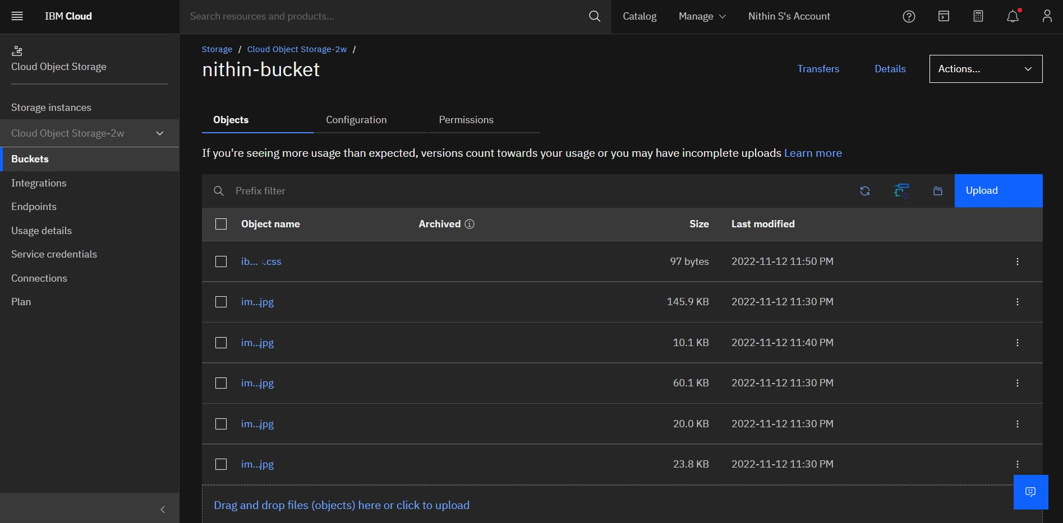

# HTML code:

<!DOCTYPE html>

<html lang="en">

<head>

<meta charset="UTF-8">

<meta http-equiv="X-UA-Compatible" content="IE=edge">

<meta name="viewport" content="width=device-width, initial-scale=1.0">

<title>Assignment 3</title>

<style>

img {

width: 200px; height: 200px; padding: 10px;

}

</style>

</head>

<body>

<title>Assignment</title>

<h1>IBM Retrieve Images from cloud</h1>

<img

src="https://s3.jp-tok.cloud-object-storage.appdomain.cloud/nithin-bucket/img1.jp g" alt="">

<img

src="https://s3.jp-tok.cloud-object-storage.appdomain.cloud/nithin-bucket/img2.jp g" alt="">

<img

src="https://s3.jp-tok.cloud-object-storage.appdomain.cloud/nithin-bucket/img3.jp g" alt="">

<img

src="https://s3.jp-tok.cloud-object-storage.appdomain.cloud/nithin-bucket/img4.jp g" alt="">

<img

src="https://s3.jp-tok.cloud-object-storage.appdomain.cloud/nithin-bucket/img5.jp g" alt="">

</body>

</html>

# Output:

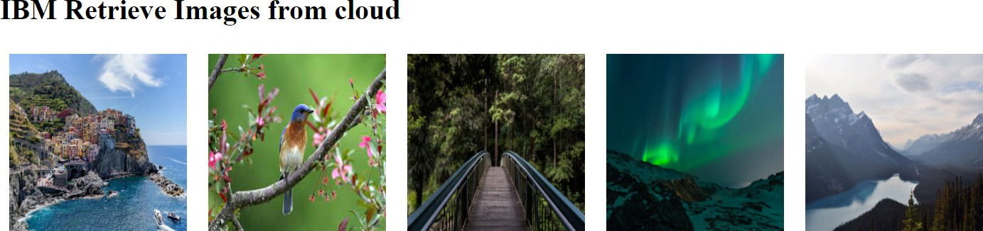

1. **Upload a css page to the object storage and use the same page in your HTML code.**

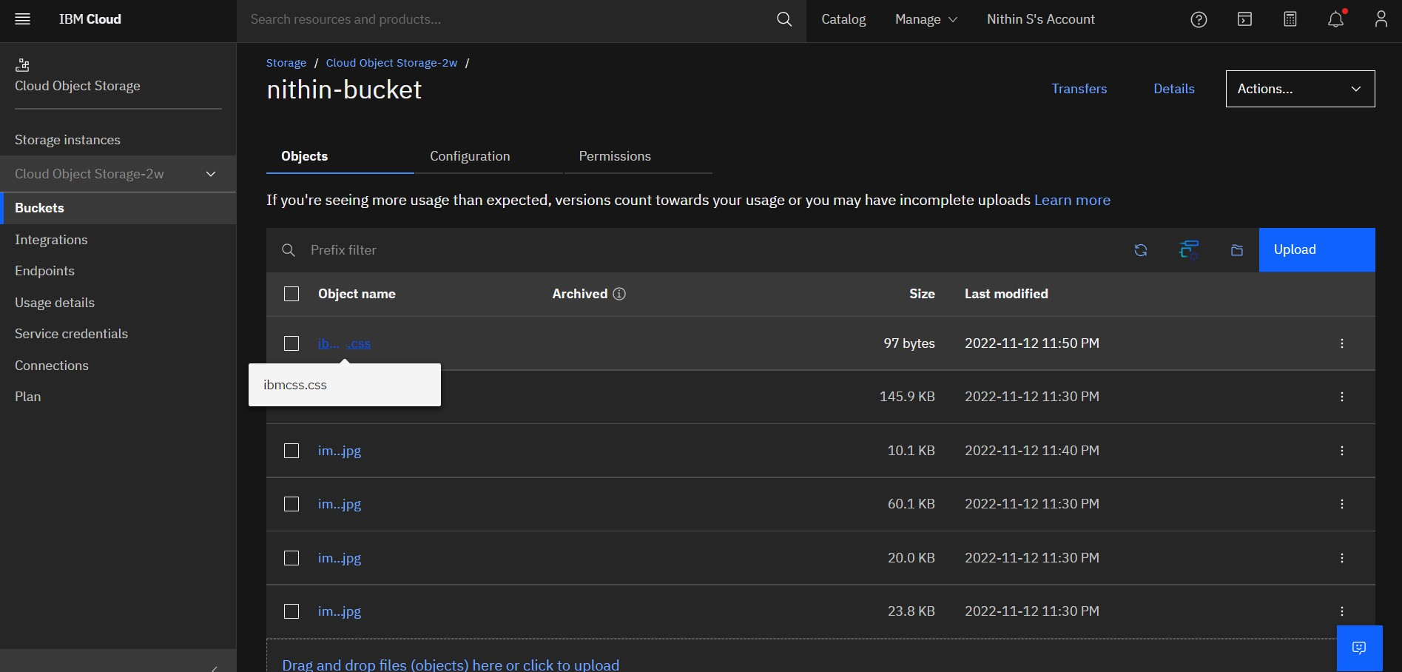

# Html code:

<!DOCTYPE html>

<html lang="en">

<head>

<meta charset="UTF-8">

<meta http-equiv="X-UA-Compatible" content="IE=edge">

<meta name="viewport" content="width=device-width, initial-scale=1.0">

<title>Assignment 3</title>

<style>

img {

width: 200px; height: 200px;

padding: 10px;

}

</style>

<link rel="stylesheet"

href="https://s3.jp-tok.cloud-object-storage.appdomain.cloud/nithin-bucket/ibmcss

.css" >

<title>Assignment</title>

</head>

<body>

<div id="imggal">

<h1>IBM Retrieve Images from cloud</h1>

<img

src="https://s3.jp-tok.cloud-object-storage.appdomain.cloud/nithin-bucket/img1.jp g" alt="">

<img

src="https://s3.jp-tok.cloud-object-storage.appdomain.cloud/nithin-bucket/img2.jp g" alt="">

<img

src="https://s3.jp-tok.cloud-object-storage.appdomain.cloud/nithin-bucket/img3.jp g" alt="">

<img

src="https://s3.jp-tok.cloud-object-storage.appdomain.cloud/nithin-bucket/img4.jp g" alt="">

<img

src="https://s3.jp-tok.cloud-object-storage.appdomain.cloud/nithin-bucket/img5.jp g" alt="">

</div>

</body>

</html>

**Output: (Borders added)**

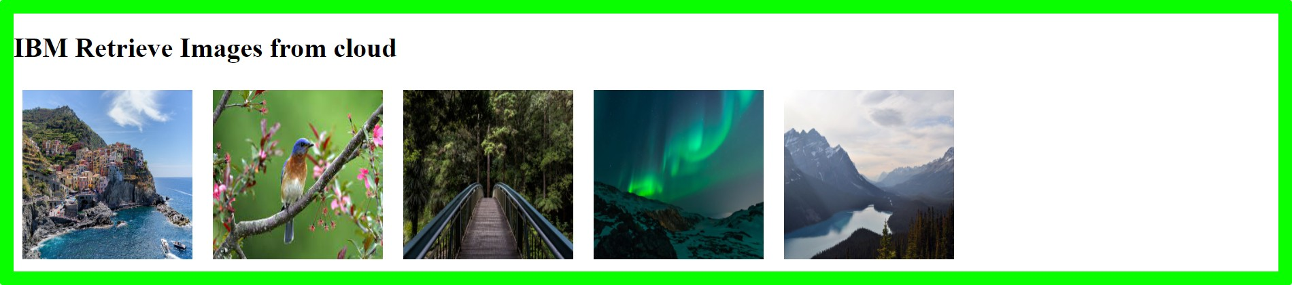

# Design a chatbot using IBM Watson assistant for hospitals. Ex: User comes with a query to know the branches for that hospital in your city. Submit the web URL of that chat bot as an assignment.

***Assistant link:***

[***https://web-chat.global.assistant.watson.appdomain.cloud/preview.html?backgroundImageURL=http***](https://web-chat.global.assistant.watson.appdomain.cloud/preview.html?backgroundImageURL=https%3A%2F%2Fus-south.assistant.watson.cloud.ibm.com%2Fpublic%2Fimages%2Fupx-99f2a8c1-6766-47aa-a798-82acfb382101%3A%3A62b51eab-32fe-4b12-a982-6614a2e6ddec&integrationID=9d50ff06-bcbe-4918-ac74-721d052b0567&region=us-south&serviceInstanceID=99f2a8c1-6766-47aa-a798-82acfb382101)[***s%3A%2F%2Fus-south.assistant.watson.cloud.ibm.com%2Fpublic%2Fimages%2Fupx-99f2a8c1-6766-47***](https://web-chat.global.assistant.watson.appdomain.cloud/preview.html?backgroundImageURL=https%3A%2F%2Fus-south.assistant.watson.cloud.ibm.com%2Fpublic%2Fimages%2Fupx-99f2a8c1-6766-47aa-a798-82acfb382101%3A%3A62b51eab-32fe-4b12-a982-6614a2e6ddec&integrationID=9d50ff06-bcbe-4918-ac74-721d052b0567&region=us-south&serviceInstanceID=99f2a8c1-6766-47aa-a798-82acfb382101)[***aa-a798-82acfb382101%3A%3A62b51eab-32fe-4b12-a982-6614a2e6ddec&integrationID=9d50ff06-bc***](https://web-chat.global.assistant.watson.appdomain.cloud/preview.html?backgroundImageURL=https%3A%2F%2Fus-south.assistant.watson.cloud.ibm.com%2Fpublic%2Fimages%2Fupx-99f2a8c1-6766-47aa-a798-82acfb382101%3A%3A62b51eab-32fe-4b12-a982-6614a2e6ddec&integrationID=9d50ff06-bcbe-4918-ac74-721d052b0567&region=us-south&serviceInstanceID=99f2a8c1-6766-47aa-a798-82acfb382101)[***be-4918-ac74-721d052b0567&region=us-south&serviceInstanceID=99f2a8c1-6766-47aa-a798-82acfb3***](https://web-chat.global.assistant.watson.appdomain.cloud/preview.html?backgroundImageURL=https%3A%2F%2Fus-south.assistant.watson.cloud.ibm.com%2Fpublic%2Fimages%2Fupx-99f2a8c1-6766-47aa-a798-82acfb382101%3A%3A62b51eab-32fe-4b12-a982-6614a2e6ddec&integrationID=9d50ff06-bcbe-4918-ac74-721d052b0567&region=us-south&serviceInstanceID=99f2a8c1-6766-47aa-a798-82acfb382101)[***82101***](https://web-chat.global.assistant.watson.appdomain.cloud/preview.html?backgroundImageURL=https%3A%2F%2Fus-south.assistant.watson.cloud.ibm.com%2Fpublic%2Fimages%2Fupx-99f2a8c1-6766-47aa-a798-82acfb382101%3A%3A62b51eab-32fe-4b12-a982-6614a2e6ddec&integrationID=9d50ff06-bcbe-4918-ac74-721d052b0567&region=us-south&serviceInstanceID=99f2a8c1-6766-47aa-a798-82acfb382101)

OUTPUT

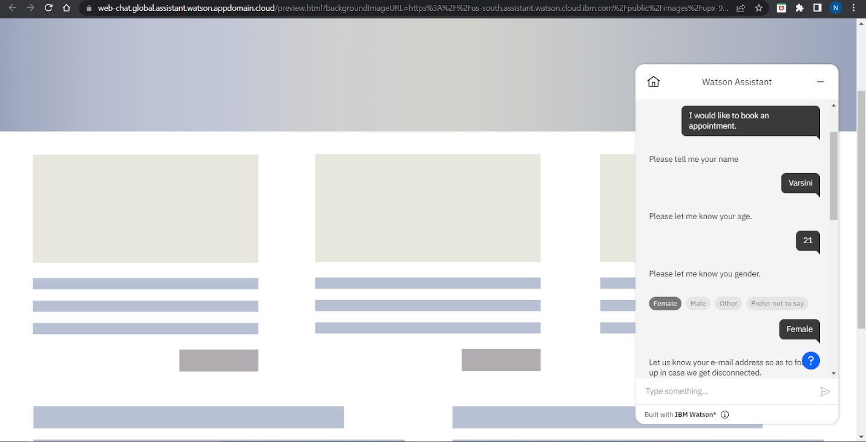

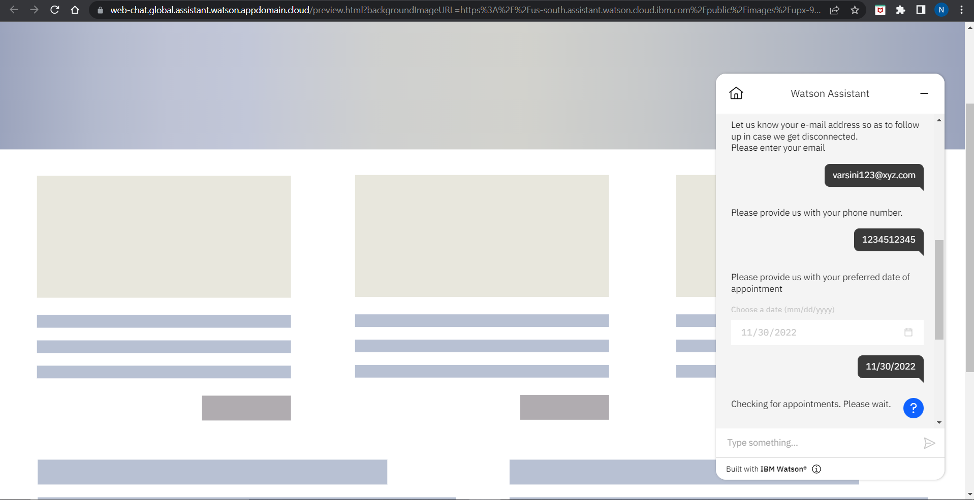

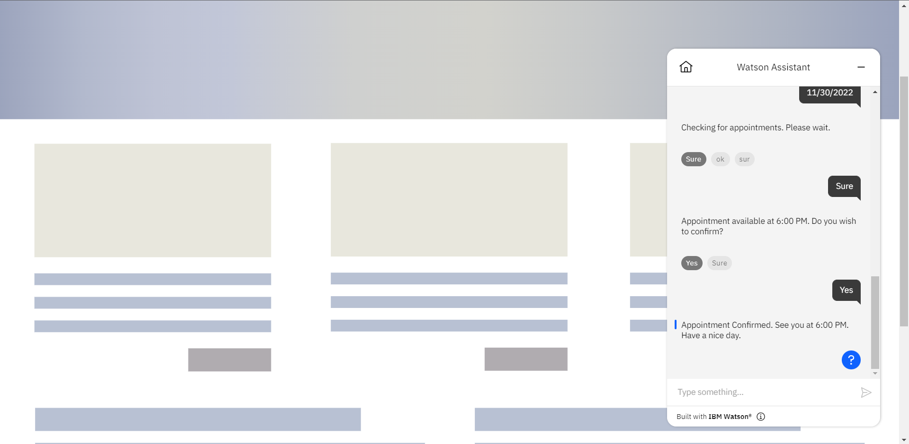

# Create a Watson assistant service with 10 steps and use 3 conditions in it. Load that script in the HTML page.

